**AKKA - Job Finder**

**Installation Guide**

**CMPE-133 - Software Engineering II**

**Team 14:**

Ayaz Azhar

Khoi Ly

Kenny Nguyen

Anh Vuong

**Instructor:** Professor Ishie Eswar

Date: 12/10/2022

**Step 1:**

Make sure you have **Python**, **NodeJS, and VSCode** installed before moving to the next step. If not, please download and install them using these following URLs:

[Download Python | Python.org](https://www.python.org/downloads/)

[Download | Node.js (nodejs.org)](https://nodejs.org/en/download/)

[Download Visual Studio Code - Mac, Linux, Windows](https://code.visualstudio.com/download)

**Step 2:**

There are two ways to clone the project:

1. Manually download the project [**here**](https://github.com/hnguyen-sjsu/job-portal)**.** Click on the **Code button** and select **Download ZIP**. A screenshot of a computer

   Description automatically generated with medium confidence
2. Using command line: Open the terminal and cd to a directory where you want to store the project at. After that, use this command to clone the project:  
   **git clone https://github.com/hnguyen-sjsu/job-portal**

**Step 3:**

After cloning the project to your local machine, you should see job-portal folder.

Double click to open job-portal folder, right-click and choose Open with Code. If you don’t have this option, you can simply copy the directory and open it inside VSCode.

**Step 4:**

1. Get the ReactJS server running
   1. Inside VSCode, open terminal. (**Ctrl + J** if you want to use shortcut)

* 1. Type **“cd client”** to go to the client directory, then **“npm install”** to install all modules and dependencies listed on package.json file. (This may take a while). If you have not installed NodeJS, this will not work.

* 1. Next, type **“npm start”** to start the React server. It will automatically render the front-end on your default browser. This is how it should look like:

1. Get the Flask server running
   1. Open another bash terminal by clicking the down arrow next to the plus sign and select **Git Bash.**

* 1. You can also split terminal for easier observation:

Under **Terminal**, select **Split Terminal** (**Ctrl + Shift + 5** if you prefer shortcut)

It should look like this:

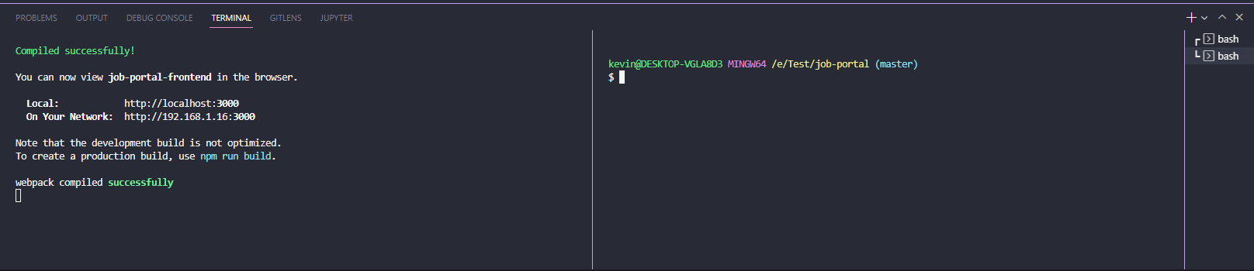

* 1. Type **“cd server”** to go inside the server folder.
  2. Type **“python -m venv venv”** to create a virtual environment for your python code. Select **Yes** if VSCode asks you to change your interpreter.

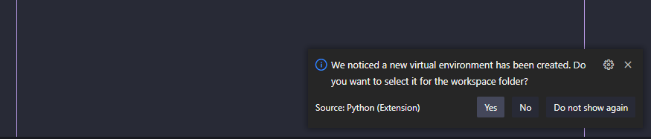

Note*: If VSCode does not ask for changing the interpreter. Press **Ctr + Shift + P** and type **interpreter**, then type **Python: Select Interpreter** and set it to the directory where the python file is located in the venv folder.



* 1. **Window OS**: Type **“source venv/Scripts/activate”** to activate your virtual environment.

**Mac OS**: Type **“source venv/bin/activate”** to activate your virtual environment.

The (venv) indicates you have activated your virtual environment.

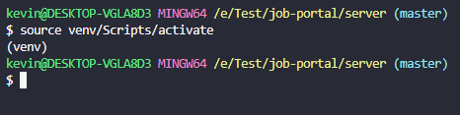

For more information about python virtual environment installation guide, please visit:

<https://docs.python.org/3/library/venv.html>

**Note*:** If you skip step d to e, all the required libraries for our back-end server will be installed into your default Python directory.

* 1. Next, **“cd code”** to go into the code folder.
  2. Type **“pip install -r requirements.txt”** to install all the libraries that we are going to use for our back-end.
  3. Type **“touch .env”** to create the environment variables. This file holds all the sensitive information of our server.

Note*: You can also manually create this file using VSCode, but make sure it is stored inside the code folder.

* 1. Open the .env file and set value of the secret keys of your choice. You can also copy and paste these values that I define here to avoid typos. For example:

JWT_SECRET_KEY="f0pFsO8jXc"

URLSafeSerializer_SECRET_KEY="recovery-secret-key"

Make sure there is no space between the equal sign. Save the changes (**Ctr + S** if you prefer shortcut).

* 1. Now, we can run out back end server by typing **“python app.py”**

If successful, the terminals will look like this:

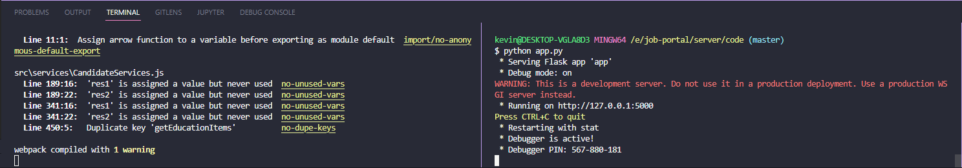

Now, you can start to register account and explore our website.

If you have any questions, feel free to email me at [khoi.ly@sjsu.edu](mailto:khoi.ly@sjsu.edu). Thank you.